YOGA Fun & Fitness
For the 3rd Grade Physical Education Classes

This week in PE class we learned about Yoga. Mr. Purdue, Mr. Schinelli and guest instructor Mrs. Zornitzer taught us different poses and exercises. This activity will help improve our knowledge of wellness and practice of fitness. In PE class we use similar exercises and skills in our Gymnastics, Motor Movement and Fitness units.

To start the practice of Yoga:
- Come into Pretzel legs (cross legs) for centering.
- Close your eyes, take 3 deep breathes and give a loud “HUMMMMMM.”

Some simple poses:
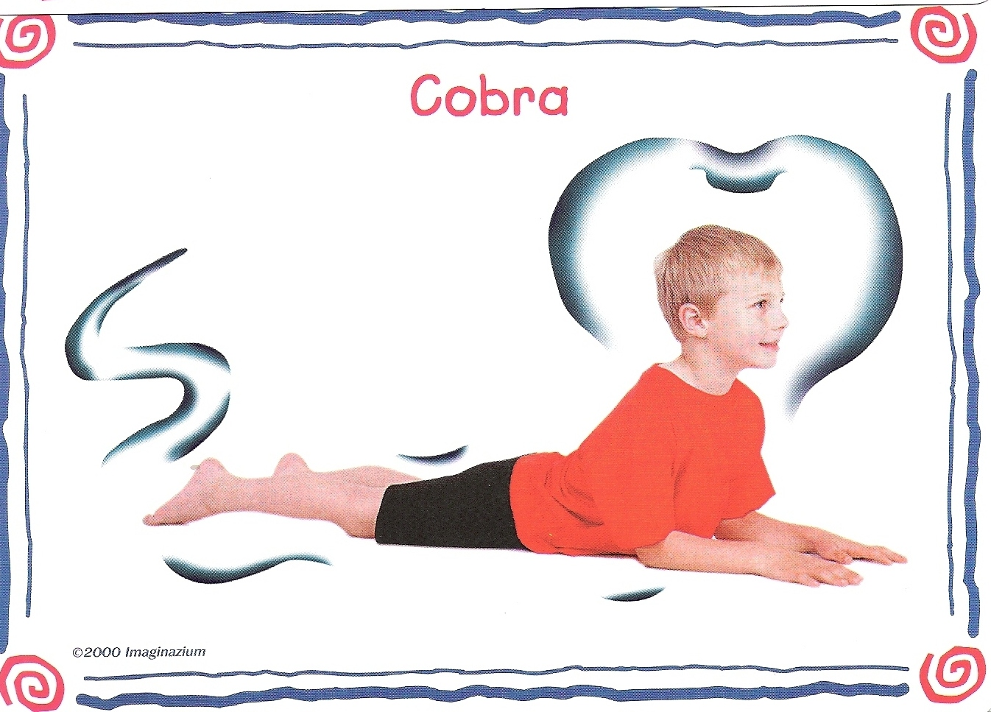 | Slither like a snake into the Cobra.  Press the hands and lift the chest.  Hold those shoulders down!  Stretches back and chest and lengthens legs.  Straighten the arms and roar to turn this pose into Lion!
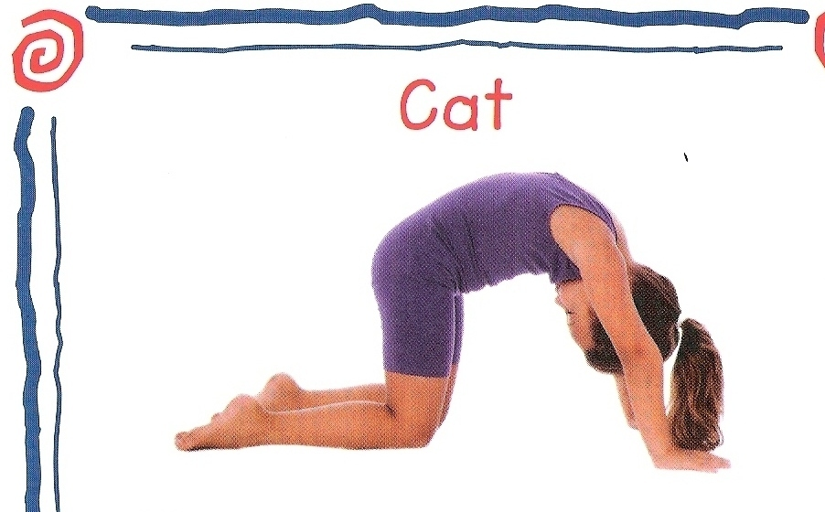 | Focus on all fours.  Round the spine and look at the belly.  Also try the opposite pose by stretching the spine in the opposite direction as you look up.
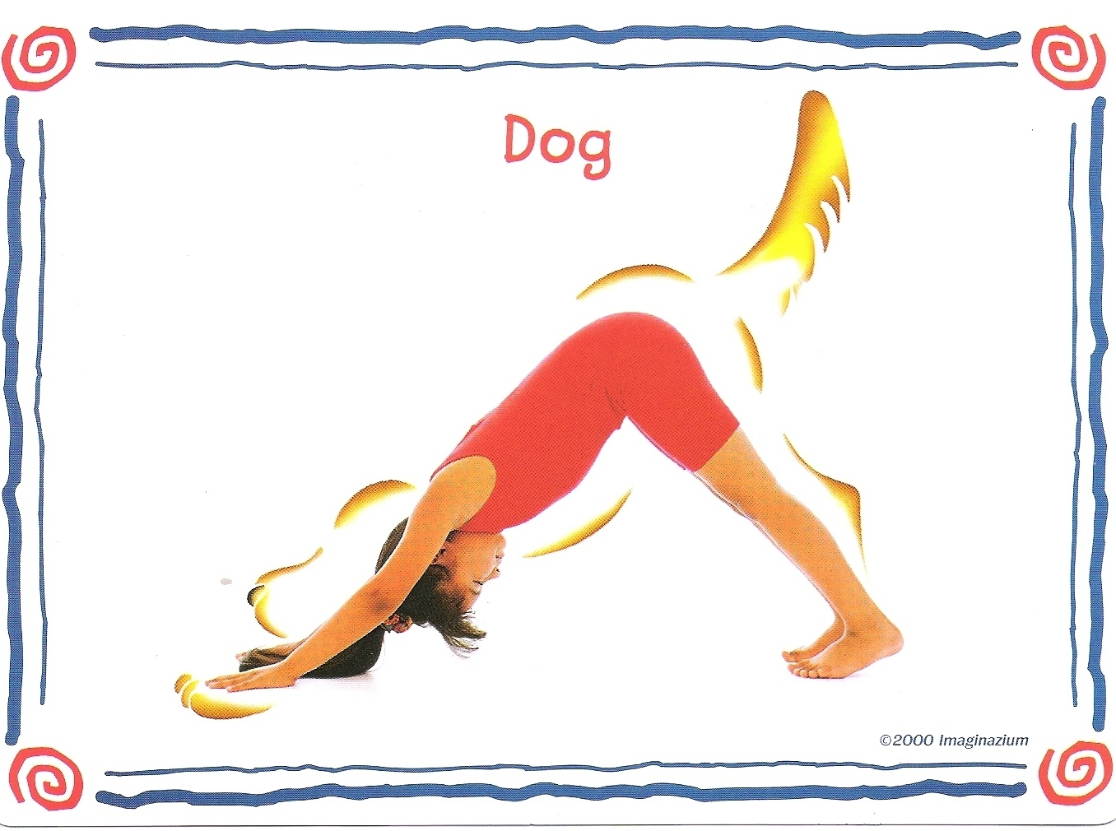 | Push into the ground to lift the tail.  Back gets long and arms stretch straight. The head hangs down.  Finally …wag your tail!
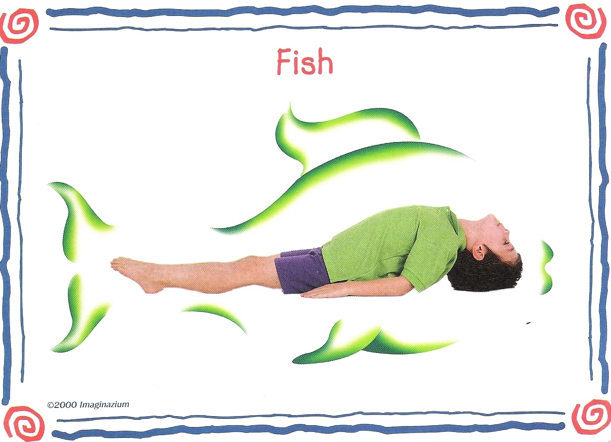 | Push the elbows down and puff the chest high.  The top of the head touches the ground. Breath into your gills.

Make up your own pose using your imagination….How about a Cat, Cow, Down & Updog, Cobra, Pigeon, Crow, Crocodile, Bear Walk, Rooster, Bird Flying into Tree ?
TURN OVER ->

Some benefits of Yoga:
- Yoga is non-competitive.
- Yoga can help you concentrate.
- Yoga can help you reduce stress and keep healthy.
- Yoga can improve your flexibility and increase your strength.
- Yoga can be done alone or with friends.
- Yoga can be done anywhere.

